**ENVIRONMENT SETUP POWERSHELL SCRIPT GUIDE**

1. Fill the details in **config.xml** needed to create the **AppPool** and **Site**. This file needs to be placed in the same folder of the script file.
2. If your PowerShell script file path contain white spaces then you have to run the ***RunPowerShellScriptWithSpacesInPath.reg*** file.
3. Double click the PowerShell script file (**EnvSetup.ps1**).
4. While running the script file if you encounter below issue

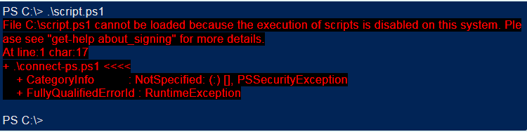

Then set the execution policy in the Powershell window as

|  |
| --- |
| **PS C:\> Set- ExecutionPolicy RemoteSigned** |

Input **“Y”** or Click **“Yes”** according the confirmation prompt displayed to change the execution policy. And double click the PowerShell script file once again.

1. The script will be executed and creates app pool and host a site in IIS.
2. Now main is the main script file. It will load the IIS_lib script

**CONFIG FILE PARAMETERS**

1) siteApppoolName-:Hosting sites app pool name

Ex-:apppool1, apppool2…etc.

2)IisAppPoolDotNetVersion-: Version of the created application pool

Ex-:v2.0, v4.0

3)enable32bit-:Do you want to enable 32bit?

Ex-: True, False

4)siteName-:Name of the hosting site

Ex-:sitename1,sitename2

5)sitePath-:The physical path of the created site

Ex-: C:\Users\MySampleApplication

6)apppoolUsername-:If the application pool runs on custom account the username here

Ex-:

7)apppoolPassword-: If the application pool runs on custom account the password here

Ex-:

8) identityType-:If we are not providing ‘apppoolUsername’ and ‘apppoolPassword’ then we can use built in account.

The possible values are ‘LocalSystem’,’Localservice’,’ NetworkService’,’ ApplicationPoolIdentity’. If not provide it will take ‘ApplicationPoolIdentity’ as default.

8)LogPath-:We need error logging. So the error logging file path here

Ex-: C:\Users\EnvSetup\logfile.log

9)port-:The port number of the hosting site.

Ex-:8091, 8092 …etc.

10) applicationPath-:The physical path of the application

Ex-:C:\Users\SampleApplication

If we dint provide value for this field application will not created

11) applicationName-:Name of the application

Ex-:SampleApplication1, SampleApplication2 …etc

12) applicationApppoolName-: Hosting applications app pool name

Ex-: ApplicationTestPool1, ApplicationTestPool2

**Default Value Parameters**

1) siteApppoolName -:TestPool

2)IisAppPoolDotNetVersion-:v4.0

3) enable32bit-:TRUE

4) apppoolUsername-:””

5) apppoolPassword-:””

6) identityType-: ApplicationPoolIdentity’

7) applicationPath -:””